PROGRAM
Wallonia meets Energy Campus Nürnberg
(Potential collaborations ideas and targeted EU call for proposals)

TOPICS
SOLAR PV/CHEMICAL STORAGE/BUILDING MATERIALS

EnCN Partners
 | Topic of Interest | Institution
Dr. Alexander Buchele | Managing Director | Energie Campus Nürnberg
Gunnar Harhausen | Building Technology | TH Nürnberg
Dr. Andreas Distler | Organic/Printed PV | ZAE Bayern
Stefan Dürr | Hydrogen Storage | FAU Erlangen-Nürnberg
Dr. Maximilian Göltz | Diamantbeschichtung | FAU Erlangen-Nürnberg
Prof. Dr. Wolfgang Krcmar | Building Materials | TH Nürnberg
Dr. Thomas Ammerl | BAYFOR | BayFor

Walloon Organisation team
 | Topic of Interest | Institution
Mr. Cédric Brüll | All topics of Interest | TWEED Cluster + Walloon companies (*)
Dr. Fabrizio Maseri | All topics of Interest | MATERIA NOVA Applied Research Centre
Dr. Hervé Brequel | Recycling, Building Materials | CTP Applied Research Centre
Ms. Olivia Deresteau | Hydrogen Storage | CERTECH Applied Reserach Centre
Dr. Catherine Archambeau  Dr. Ahmed Rassili | All topics of Interest | CRM - Applied Research Centre
Dr. Dodji Amouzou | All topics of Interest | UCL – Université Catholique de Louvain
Mr. Pierre Fiasse | All topics of interest | NCP (National Contact Point Wallonia)
Mr. Mathieu Quintyn | All topics of interest | WBI (Wallonie Bruxelles International)
(*) Walloon consortium regarding the initiative, but we are expected around 30 Walloon players regarding the WORKSHOP on December 9th

Agenda

Sunday, December 8th
Welcome in Brussels (Visit and Diner at the city-center)
Transfers, Visit and Dinner are organized by WBI

- 17:30 –19:00 : GUIDED TOUR of the City-Centre of BRUSSELS (in GERMAN)
Meeting point: LOBBY of the Motel One (120, rue Royale à 1000 Bruxelles)
Phone number of our German Guide Achiel : +32 494 06 69 31

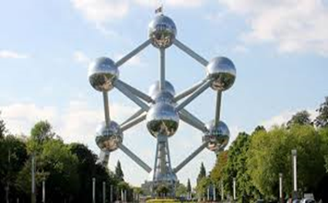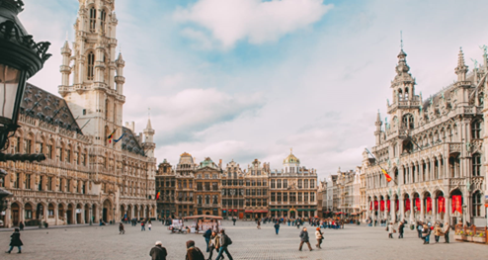

- 19:30 –22:30 : Welcome dinner offered by WBI

Restaurant VINCENT
Rue des Dominicains 8
1000 Bruxelles

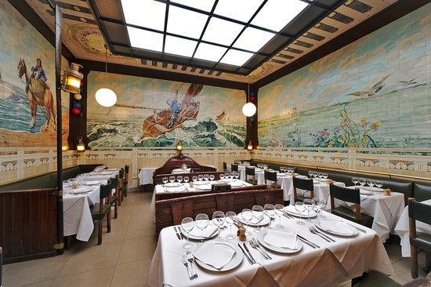

Monday, December 9th
Location : Cercle du Lac Business Club - Boulevard Baudouin 1er 23, 1348 Ottignies-Louvain-la-Neuve
SALLE BAIKAL
Transfers is organized by WBI

- 08:30 – 9:00 : Registration

- 09:00 – 9:30 : Welcome Adress and Introduction Speeches
09:00 – 9:15 : Cédric Brüll (Managing Director of TWEED Cluster)
Presentation of the Energy Walloon Ecosystem
09:15 – 09:30 : Dr. Alexander Buchele (Managing Director of Energy Campus Nürnberg)
General overview of the Energy Campus Nürnberg

- 09:30 – 10:30 Presentation of the delegation of the Energy Campus Nuremberg
(10 min Impulse Introduction for each Bavarian Scientists – Topics and idea projects)
09:30 – 09:40: Gunnar Harhausen (TH Nürnberg) – Building Technology
09:40 – 09:50: Prof. Dr. Wolfgang Kcmar – Building Materials
09:50 – 10:00: Dr. Andreas Distler – Organic/Printed PV
10:00 - 10:10: Stefan Dürr – Hydrogen Storage
10:10 – 10:20: Dr. Maximilian Göltz – Materials
+ Questions

- 10:30 – 10:45 Coffee break

- 10:45 – 11:30 Challenges for the Walloon industries
10:45 – 11:05: Dr. Sébastien Borguet (Head of R&D - John Cockerill) – “Hydrogen technology John Cockerill”
11:05 – 11:25: Dr. Marc Foguenne, (Technology and Innovation Director, AGC Glass Europe). – “ The Energy challenge : a trigger of ambitious and innovative projects.”
+ Questions

- 11:30 – 13:00 : Networking Dinner + Round Tables dedicated to the 3 main topics
Solar PV / Chemical Storage / Building Materials & Technology
Supported by: Pierre Fiasse (NCP-Wallonie) - Head of NCP WALLONIA
Dr Thomas Ammerl (Bavarian Research Alliance GmBH) - Head of Unit
Energy, Environment and Bioeconomy

- 13:00 – 17:00 Guided Tour (Open for Walloon R&I stakeholders)
#Solaire | #ChemicalStorage  #Hydrogen | #BuildingMaterials
CRM GROUP/ELYOSIS  Rue des pôles 1, 4000 Liège  Catherine Archambeau : catherine.archambeau@crmgroup.be  Ahmed Rassili:  ahmed.rassili@crmgroup.be | MATERIA NOVA  Avenue Nicolas Copernic 3, 7000 Mons  Fabrizio Maseri : fabrizio.maseri@materianova.be | CENTRE TERRE&PIERRE  Chaussée d’Antoing 55, 7500 Tournai  Hervé Brequel :  herve.brequel@ctp.be
14:00 – 15:30 (duration: 1:30)  - BIPV :  - Metal roll to roll pilot lines in clean room environment / printed electronic technologies and applications  - Steel solar roof (pilot)  - Eliosys company facilities (partner of CRM group for solar PV solution characterization and validation)  - Hydrogen:  - Specific testing methods (diffusive Hydrogen measurement iso17025 testing)  - Fuel cell applications demo  Transfer 20 min | 14:00 – 15:30 (duration: 1:30)  - Construction materials : Bio-sourced materials (binders, foams, additives) - Reactive extrusion pilots Lab  - Energy conversion & Storage : Plasma functional Lab. on solid products, Plasma Catalytic Reforming tools (gas, liquids) – Testimony of GREENFRIX SME (to be confirmed)  - Organic / Printed PV : OPV/OLED pilot tool : new optronic materials, transparent film barriers, advanced characterizations – Presence of an expert in advanced modelling from UMons)  Transfer 30 min | 14:30 – 16:30 (duration: 2:00)  - Visit of recycling pilot facilities (7000m²)  - Physical separation of demolition waste (combination of grinding, sieving and densimetric separation tools either in dry or wet processes)  - Valorisation of composite materials (glass or carbon reinforced plastics)  - Cement and concrete formulation lab incorporating mineral waste materials / insulating materials from demolition waste using biosourced foaming agent  - Visit of hydrometallurgy / electrochemistry lab  - Presentation of first results using diamond.d electrodes for metal extraction from industrial waste  - Tour of the lab  Transfer 1h15 min (BRU)
MATERIA NOVA / IONICS FACILITIES  Rue des Alouettes 1, 4042 Herstal  Fabrizio Maseri : fabrizio.maseri@materianova.be | CERTECH  Rue Jules Bordet, 7180 Seneffe  Olivia Deresteau : olivia.deresteau@certech.be
15:50 – 16:30 (duration 30 min)  Walibeam Technological platform. Engineering office – Presentation of the project and several pilots for industrial ion implantation technology (Ion Lab, Large S2S, powders)  Transfer 1h30 (BRU) | 16:00 – 17:15 (duration 1h15)  - Certech presentation : polymer materials technology, process intensification and environment, with a specific focus on hydrogen storage in porous materials  - Tour of the laboratories and of the implementation hal  Transfer 40 min (BRU)
Dr. Andreas Distler  Dr. Thomas Ammerl | Dr. Alexander Buchele  Stefan Dürr | Dr. Maximilian Göltz  Prof. Dr. Wolfgang Krcmar  Gunnar Harhausen
Tranfers from Applied Research Centers to Brussels are assured by WBI
- 18:00 – 22:00 Evening : Bavarian Christmas Reception at the Bavarian EU Representation – Rue Wiertz 77, 1000 Bruxelles

Nürnberg – Weihnachtsstadt trifft Innovation
Seit Jahrhunderten ist Nürnberg für Menschen und Unternehmen das Tor zur Welt. Die bewegte Geschichte verflochten mit Erfindergeist, Kreativität und Innovationskraft bilden auch heute den einzigartigen Charakter der Stadt. Als High-Tech-Standort und kultureller Hotspot zugleich wird Nürnberg weit über die Metropolregion hinaus international geschätzt.
Alljährlich verwandelt sich Nürnberg pünktlich zu Beginn der Adventszeit in eine rot-weiße Weihnachtsstadt. Auf dem Christkindlesmarkt erklingen zwischen den festlich geschmückten Buden weihnachtliche Lieder, der Duft von Lebkuchen und Glühwein weht über den Hauptmarkt und sanfte Lichter erleuchten die Straßen. Die magische Kombination aus Tradition und urbanem Flair verzaubert Gäste aus aller Welt und verdeutlicht das Lebensgefühl der Stadt.
Wir laden Sie herzlich ein, die einzigartige Atmosphäre der Nürnberger Weihnacht am 9. Dezember 2019 bei Lebkuchen, Glühwein und fränkischen Spezialitäten in Brüssel zu genießen und sich vom Prolog des Nürnberger Christkinds auf die Weihnachtszeit einstimmen zu lassen.

Der Leiter der Staatskanzlei und Staatsminister für Bundes- und Europaangelegenheiten und Medien
Dr. Florian Herrmann, MdL
und
der Oberbürgermeister der Stadt Nürnberg Dr. Ulrich Maly

bitten zu einem Abend im Advent am Montag, 9. Dezember 2019, 19:30 Uhr,
(ab 18:30 Uhr: Einlass und Vorempfang mit Glühwein im Innenhof der Vertretung

Tuesday, December 10th – Visit of Scientific Park of LAB Tour of University Catholic of Louvain and/or AGC GLASS sa
08:30 – 09:00 : Welcoming and splitting of the delegation in two groups – UCL
Salle Oleffe, Halles Univesitaires
Place de l’université 1, 1348 Louvain-la-Neuve.
GROUP 1  UCLouvain- ICTEAM  Avenue Georges Lemaitre 4, 1348 Ottignies-Louvain-la-Neuve  Stefan Dürr, Maximilian Göltz, Dr. Andreas Distler, Dr. Alexander Buchele | GROUP 2  UCLouvain- LOCI  Place du Levant 1, 1348 Ottignies-Louvain-la-Neuve  Prof Wolfgang Krcmar, Dr. Thomas Ammerl, Gunnar Harhausen
PV-Solar Guided Tour  09:00 – 10:00 : PV-Solar. Guided Tour of UCLouvain cleanroom (WINFAB)  by Prof. Denis Flandre and Dr. Sébastien Faniel | Energy Building Guided Tour.  09:00 – 09:45 : Visit of LOCI (department of architecture)  Prof. Sergio Altomonte and Prof. Daniela Perroti and Dr. Gabrielle Masy  09:45 – 10:30 : Visit of department of construction  Prof. Catherine Doneux, Prof. Pierre Latteur et M. Alex Bertholet.
  10:00 – 10:30 : Guided tour of the UCLouvain platform for electrical measurements
  Dr. Valeriya Kilchytska
10:30 : Splitting into groups : UCL Bioenergy lab/Chemical storage or AGC Glass
GROUP 3  UCL  Stefan Dürr, Maximilian Göltz, Dr. Thomas Ammerl, Dr. Alexander Buchele | GROUP 4 – Transfer From LLN to Gosselies  Rue Louis Blériot 12, 6041 Gosselies  Prof Wolfgang Krcmar, Dr. Andreas Distler, Gunnar Harhausen
Chemical storage- Hydrogen Guided Tour  10:15 – 10:45 : Guided Tour of the UCLouvain’s SpinOff in hydrogen production  Prof. Joris Proost;  10:45 – 11:15 : Guided Tour of Hydrogen storage manufacturing  Prof. Yaroslav Filinchuk  11:15 – 11:50 : Visit of laboratories dedicated to batteries  Prof. Jean-François Gohy and Prof. Alexandru Vlad | Guided Tour at AGC  11:20 – 11:30: Café  11:30 - 11:40 : AGC Glass Europe short Introduction to the R&D Technology and Innovation organization  (Ir. Vincent Lieffrig)  11:40 – 12:45 : Building and Energy with AGCs’ presentations and exchanges  (Ir. Nadia Jacobs, Dr. Daphne Stassen, Dr. Michaël Demeyere, Ir. Tanguy Timmermans)
12:00 -13:00 LUNCH | 12:45 – 13:10 LUNCH (Sandwiches)
Guided Tour of the bioenergy lab  13:00 – 14:00 : Presentation of the activities of UCLouvain in biomass, bioenergy, etc.  Prof. Hervé Jeanmart. | Guided Tour at AGC  13:10 – 13:50 : Discovery room  13:50 – 14:00 : End

